Creating EC2using Terraform
step 1- VS Code
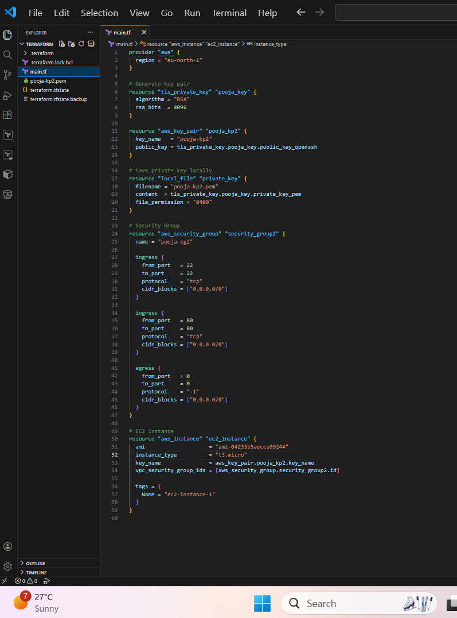
- Creates Keypair
- Creates Security group
- Creates instance
- Can connect to instance
- Output

